Lesson 5 Demo 3
Creating a Freestyle Build Job

Objective: Create a freestyle build job

Tools required: Git, GitHub, and Jenkins

Prerequisite: Make sure you have a Github Account available. If not, please create one using the given link.
https://github.com/join?ref_cta=Sign+up&ref_loc=header+logged+out&ref_page=%2F&source=header-home

Please ensure you have jenkins installed in order to proceed. In case you don’t have it installed, you can refer to demo 1 of lesson 5 to install jenkins.

Steps to be followed:
- Create a GitHub repository
- Add a Java program to the repository
- Create a freestyle build job in Jenkins
- Build the Java program with Jenkins

Step 1: Create a GitHub repository
  - Open the browser in your lab.

  - Go to https://github.com/ link.
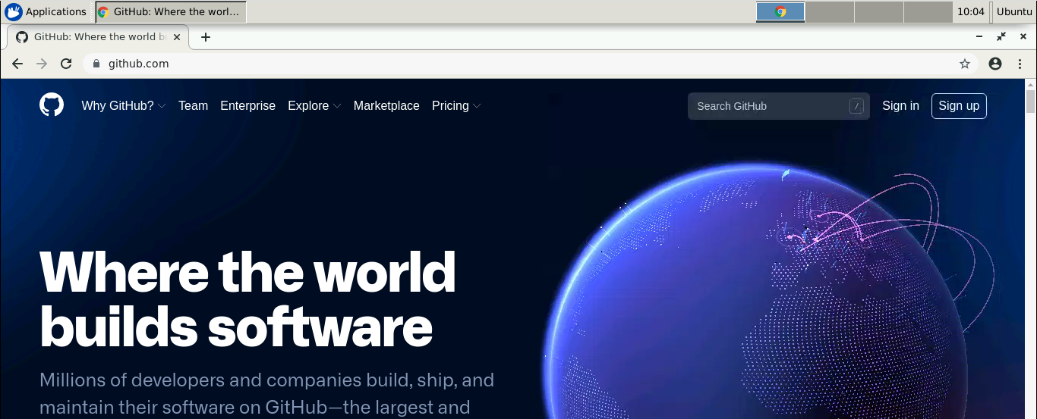

  - Click on Sign in and enter the credentials of your GitHub account to login.
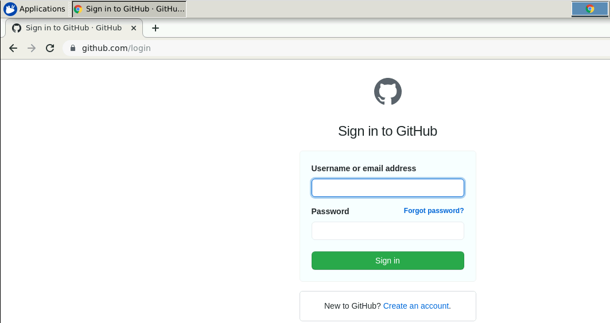

  - Click on + symbol and select New repository.
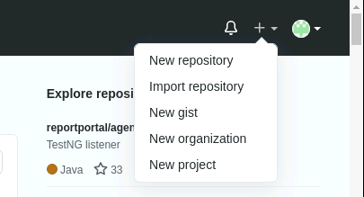

  - Provide the repository name.
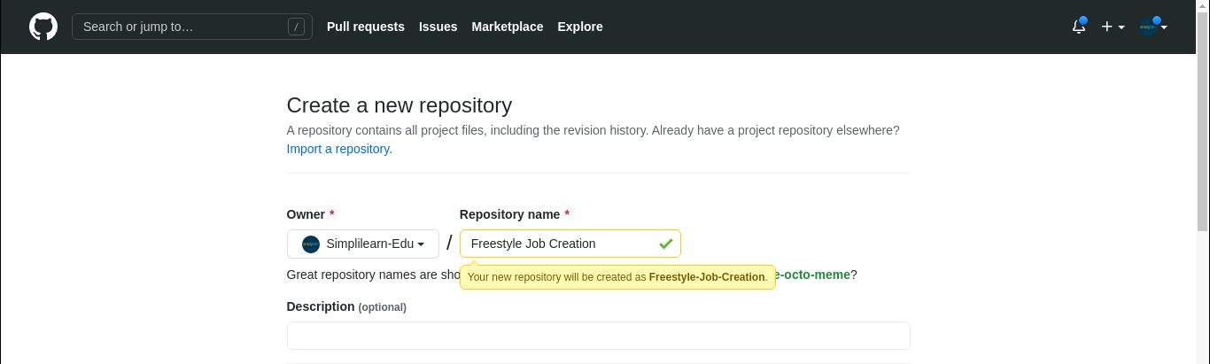

  - Select the check box of ADD a README file and click on Create repository.
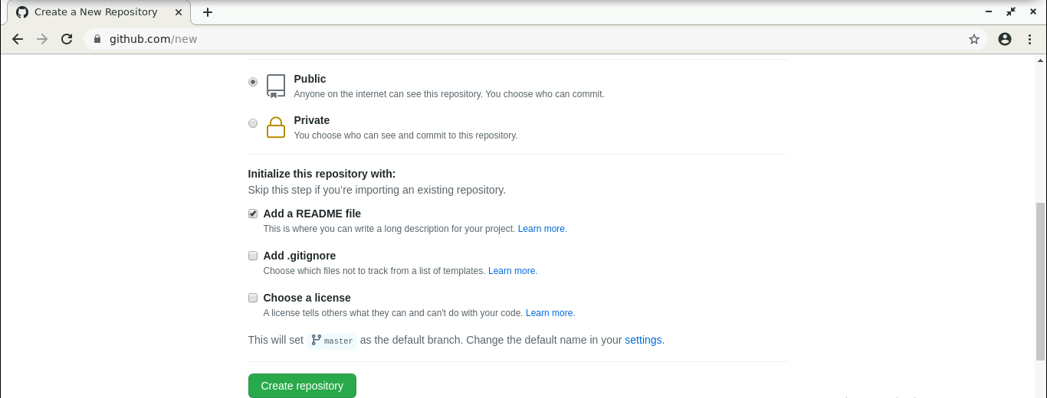

  - Click on Code.
  - Click on HTTPS.
  - Copy the repository URL.
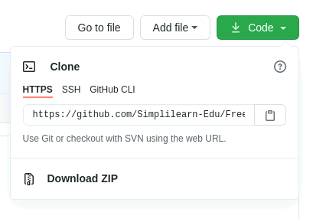

Step 2: Add a Java program to the repository

  - Open the terminal.
  - Run mkdir hello-world to create a directory.
  - Navigate to the hello-world directory. Run cd hello-world command.
  - Run vi HelloWorld.java to open the java file in a text editor.



2.5 Paste the code below into the file:

public class HelloWorld {
public static void main(String[] args) {
System.out.println("Hello, World");
}
}
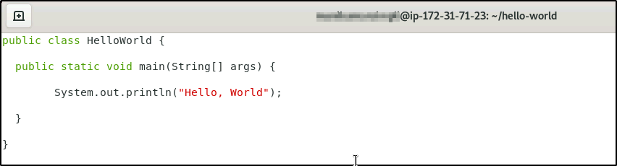

  - Save the file and exit the text editor.

  - Run the git init command.
  - Run git add . command.
  - Run git commit -m “Add new files” command.
  - Run git remote add origin <Repository_URL> command.
  - Run git push -u origin master command.

Step 3: Create a freestyle build job in Jenkins
  - In the browser, type localhost:8080 and it will open Jenkins.
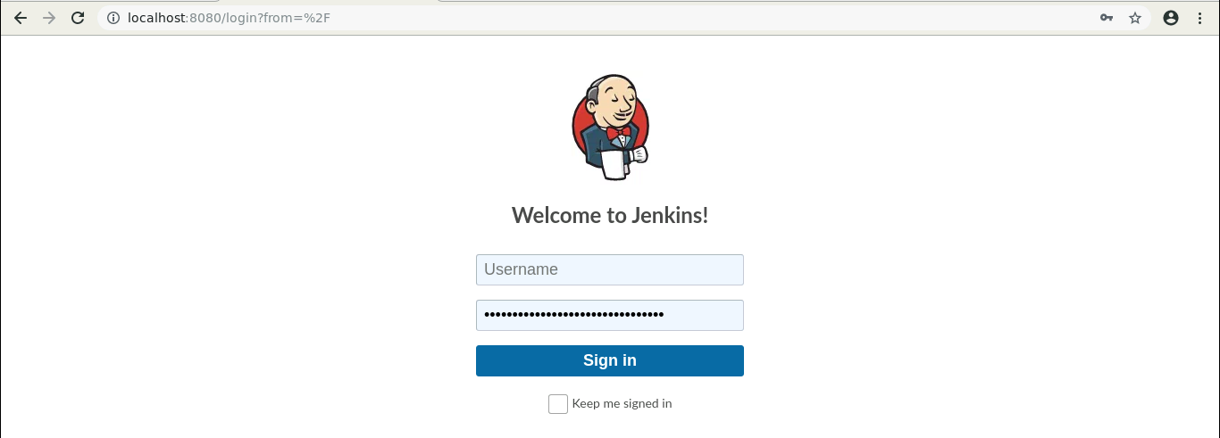

  - Provide the credentials and click on Sign in.
  - Click on New Item in the Jenkins dashboard.
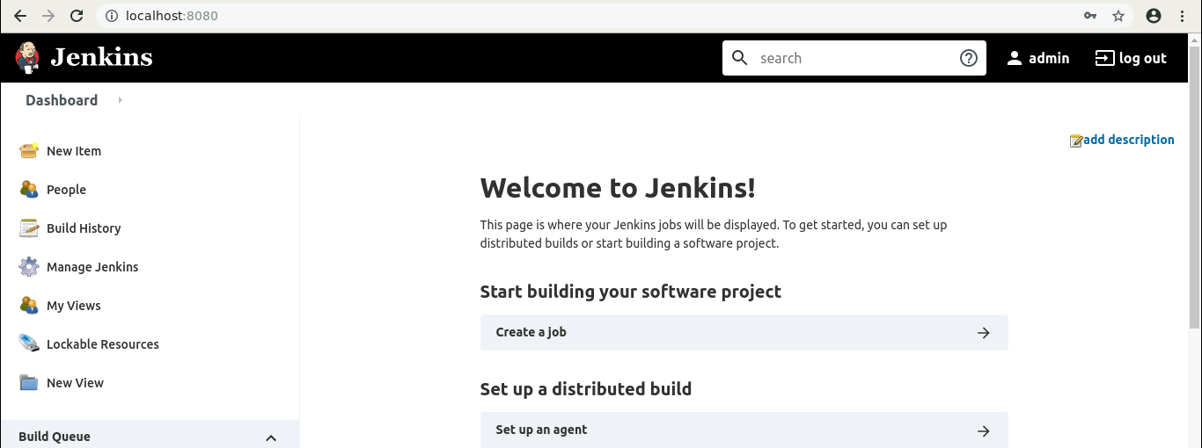

  - Enter a name for your project.
  - Select Freestyle project as the build job type.
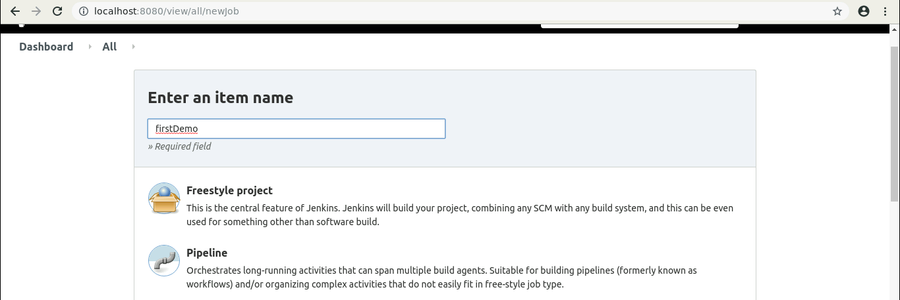

  - Click on OK.

  - Scroll down to the Source Code Management section and select Git.
  - Enter the repository URL.
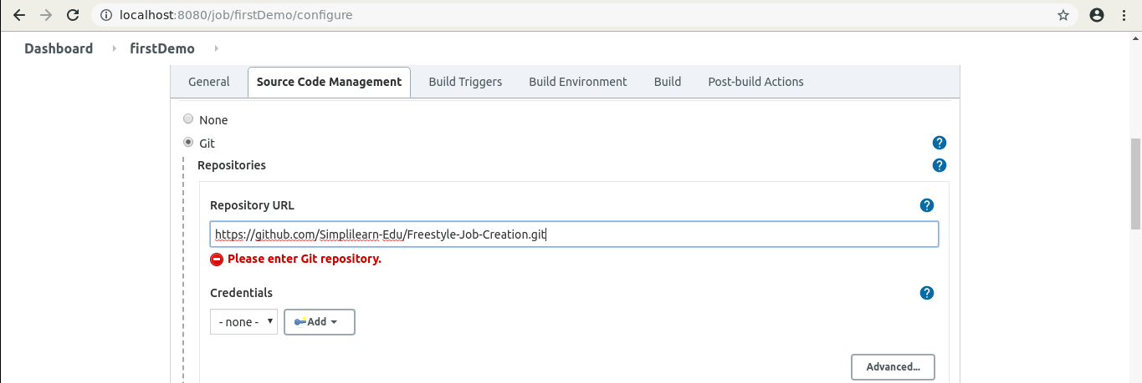

  - Click on Save.

Step 4: Build the Java program with Jenkins
  - Click on the project name in the Jenkins dashboard.
  - Click Build Now in the project window. Jenkins will now build your project.
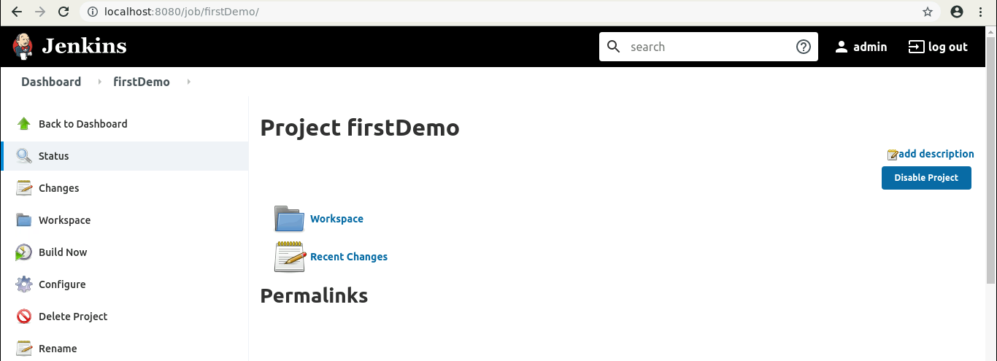

  - Click on Build History to view the build results.
4.4 Click on the Console Output to view the build logs.
